**INTI International College Penang School of Engineering and Technology**

**3+0 Bachelor of Science (Hons) in Computer Science, in collaboration with Coventry University, UK**

**3+0 Bachelor of Science (Hons) in Computing, in collaboration with Coventry University, UK**

**Coursework cover sheet**

**Section A - To be completed by the student**

|  |  |
| --- | --- |
| Full Name: MAH CHUN-HOE | |
| CU Student ID Number: P22014268 | |
| Semester: 1 | |
| Session:  **August 2022** | |
| Lecturer:  **Nadhrah Abdul Hadi (nadhrah.abdulhadi@newinti.edu.my)** | |
| Module Code and Title:  **4067CEM Software Design** | |
| Assignment No. / Title:  **Continuous Assessment** | % of Module Mark:  **50** |
| Hand out Date:  **6th September 2022** | Due Date:  **Task 1: 30 September 2022, by 11.59pm.**  **Task 2: 18 November 2022, by 11.59pm**  **Task 3: 4 November 2022, by 11.59pm.**  **Task 4: 4 November 2022, by 11.59pm.**  **Task 5: 4 November 2022, by 11.59pm.** |
| Penalties: No late work will be accepted. If you are unable to submit coursework on time due to extenuating circumstances, you may be eligible for an extension. Please consult the lecturer. | |
| Declaration: I/we the undersigned confirm that I/we have read and agree to abide by the University regulations on plagiarism and cheating and Faculty coursework policies and procedures. I/we confirm that this piece of work is my/our own. I/we consent to appropriate storage of our work for plagiarism checking.    Signature(s): ________________________ | |

**Section B - To be completed by the module leader**

|  |  |  |
| --- | --- | --- |
| Intended learning outcomes assessed by this work:  1. Understand and apply appropriate concepts, tools and techniques to each stage of the software development  2. Understand and apply design patterns to software components in developing new software  3. Demonstrate an understanding of project planning and working to agreed deadlines, along with professional, interpersonal skills and effective communication required for software production  5. Demonstrate an awareness of, and ability to apply, social, professional, legal and ethical standards as documented in relevant laws and professional codes of conduct such as that of the Malaysian National Computer Confederation. | | |
| Marking scheme | Max | Mark |
| 1. User Story Mapping 2. Setting up a GitHub Repository 3. Creating a Class diagram and design pattern selection 4. Creating a Prototype User Interface and Usability Testing 5. Discuss the ethical issue related to the software | 20  10  30  20  20 |  |
| Total | 100 |  |

**Task 1 – User Story Mapping**

**College Buddy System for Students**

**Description:** A Student Buddy System is a platform where new students can interact with many of their seniors and also course mates online. This system helps new students to be more familiar with their new school from the help of seniors. Seniors can introduce freshmen to everything happening around the school, the facilities, the clubs or societies available and many more. Seniors can also help out with their studies if they need any. This system promotes the school to become a more inclusive environment for everyone from different backgrounds. International students will benefit from this system the most as they are miles away from home. Seniors will learn to take on responsibility in guiding the new students, while freshmen know that they will have someone they can trust whenever they come across any obstacles. With this system, freshmen can learn a lot of thinking skills or problem-solving skills as they interact with their seniors. This is vital for them as they can apply these skills when they are in the industry. The Student Buddy System will deeply change the school into a more welcoming, interactive and sociable environment for all, without losing out the minorities.

**Vision:** This system is designed to help freshmen interact with their seniors when they need help as they have just been put into a new environment. The seniors and freshmen can then get to know more of each other through interactive games in the system or by scheduling an outing. This system hopes to promote a more inclusive environment for everyone from different backgrounds.

**Targeted User:** Students in INTI International College Penang

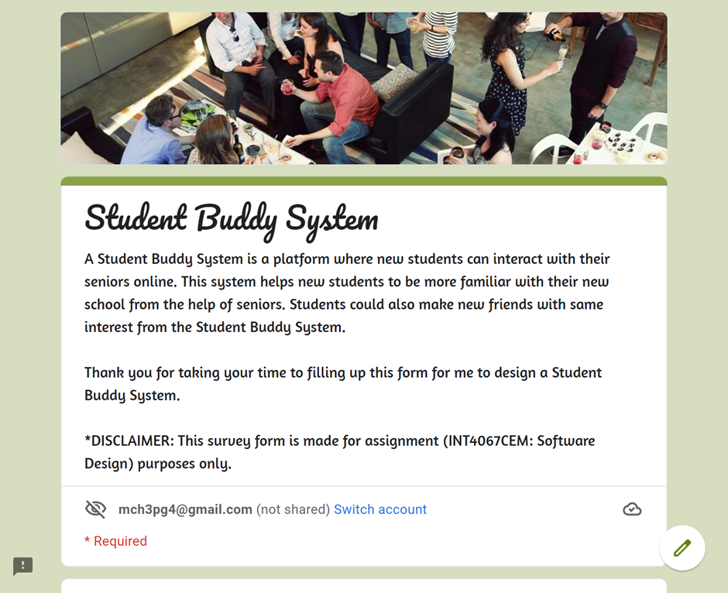

Figure 1: Student Buddy System Survey Form

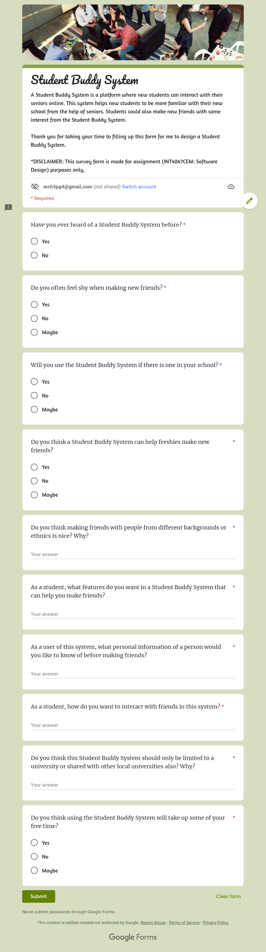

Figure 2: Student Buddy System Survey Form

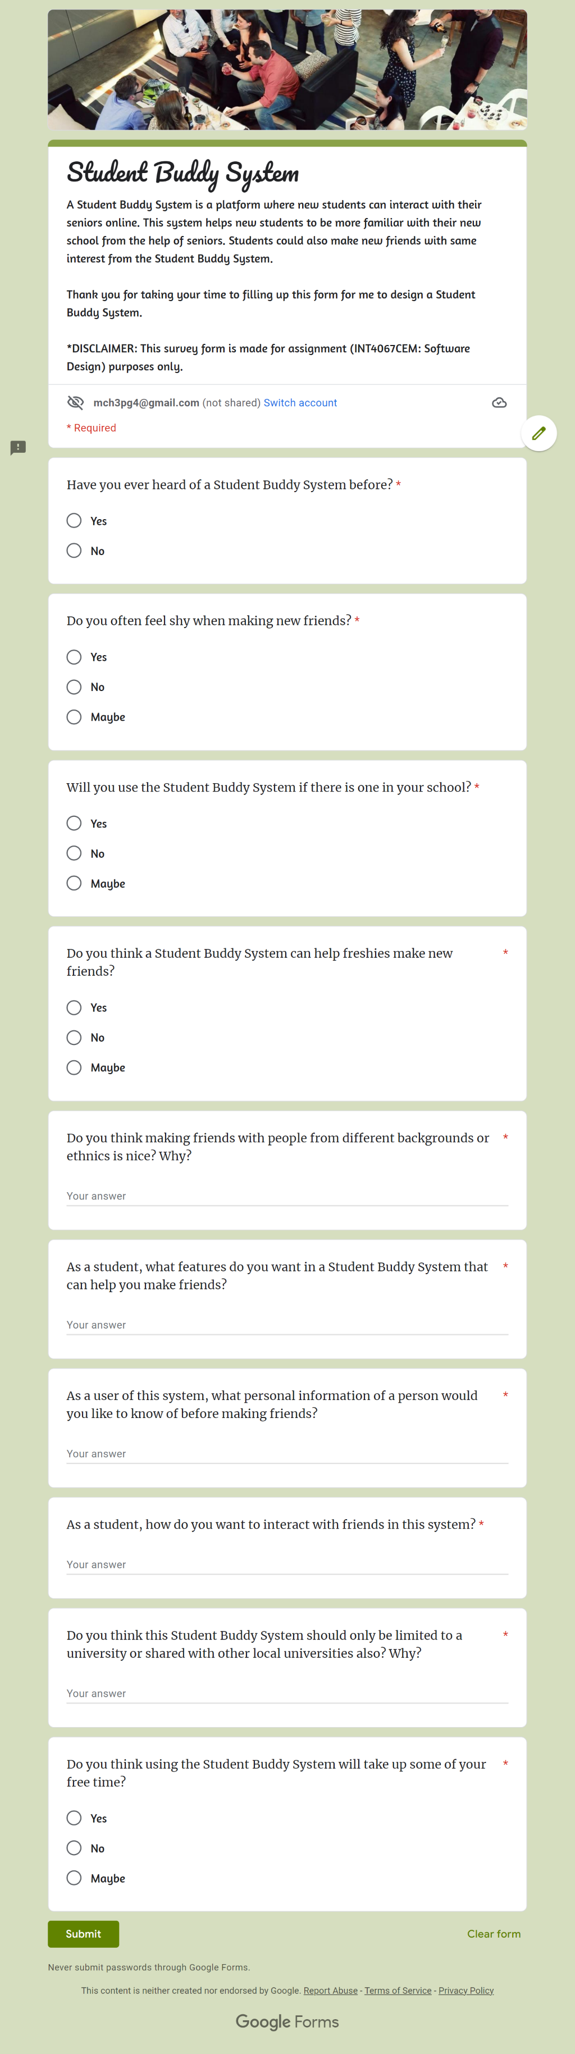

Figure 3: Student Buddy System Survey Form

Figure 4: Student Buddy System Survey Form

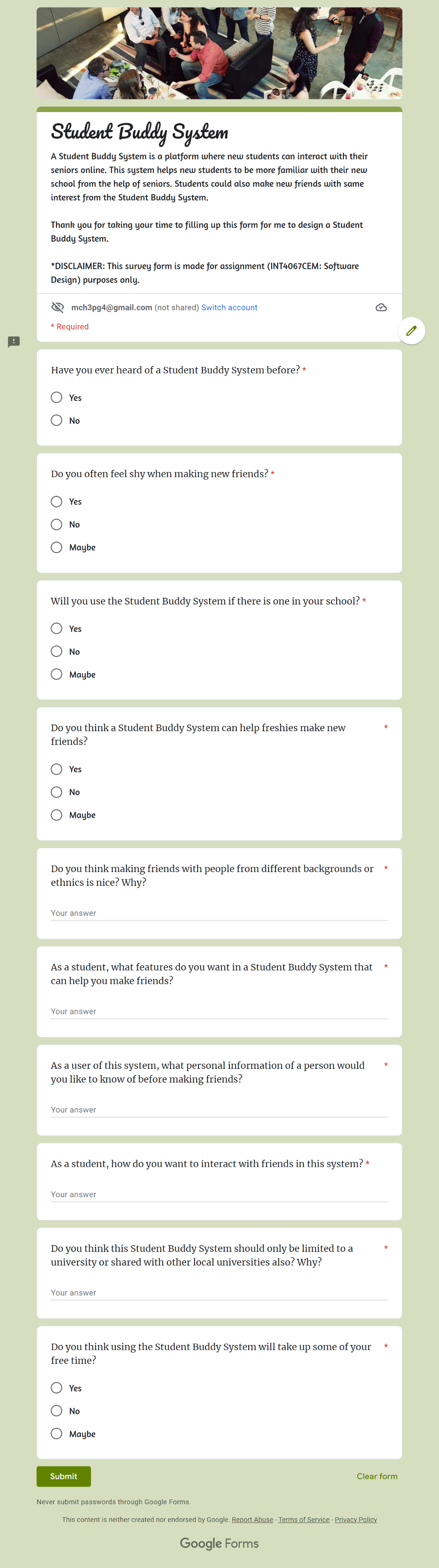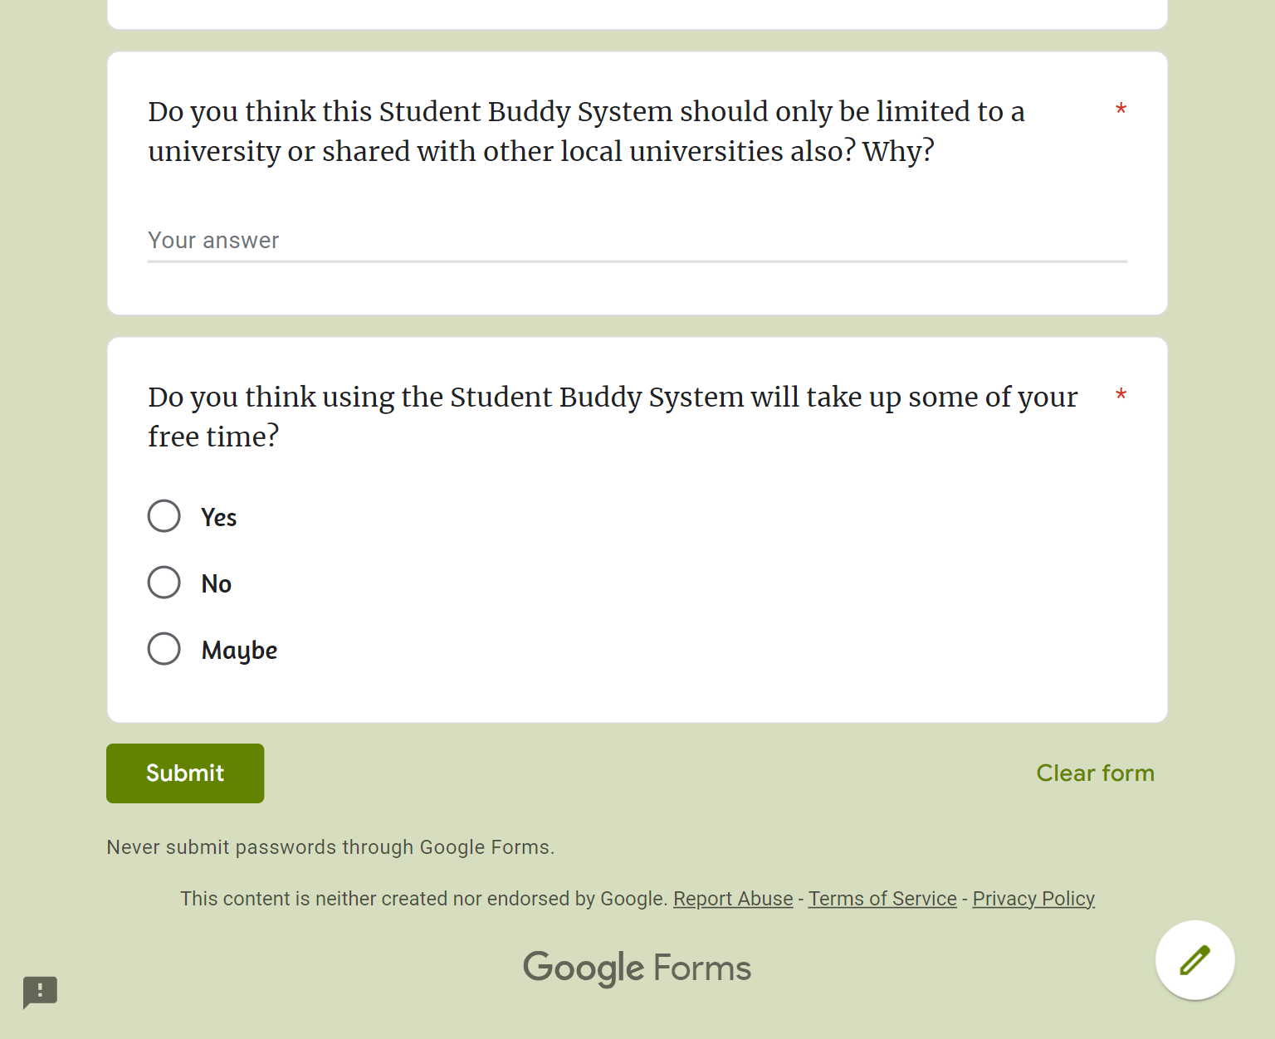

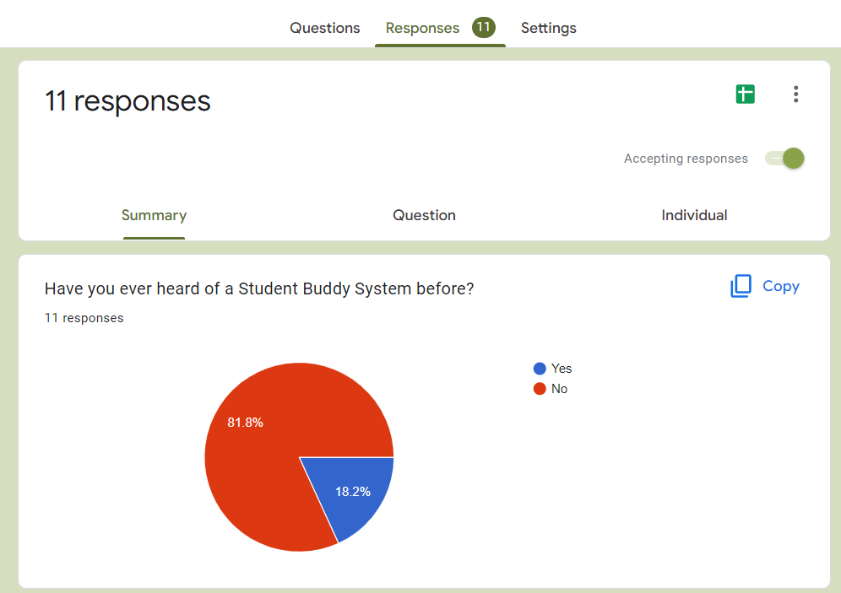

Figure 5: Student Buddy System Survey Responses

**Analysis:** Up to 80% of students have not heard of a Student Buddy System before, while about 20% of students have heard of this system before.

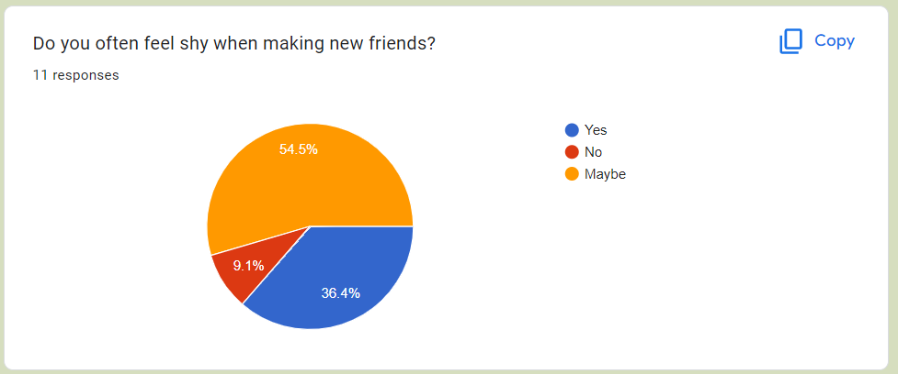

Figure 6: Student Buddy System Survey Responses

**Analysis:** From the pie chart above, majority of the students are sometimes shy when making new friends. Two-thirds of students are shy when making new friends, while a minority of the students are not shy at all when making new friends.

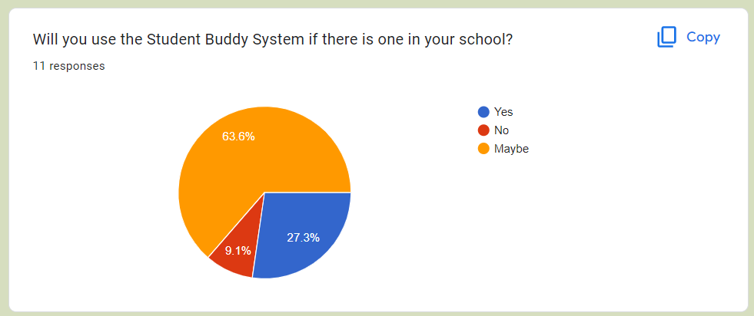

Figure 7: Student Buddy System Survey Responses

**Analysis:** Based on the results above, more than half of the students might use the Student Buddy System if it is available in their school, while around 25% of students will definitely use it in their school. A minority of students choose not to use this system even if it is available in their school.

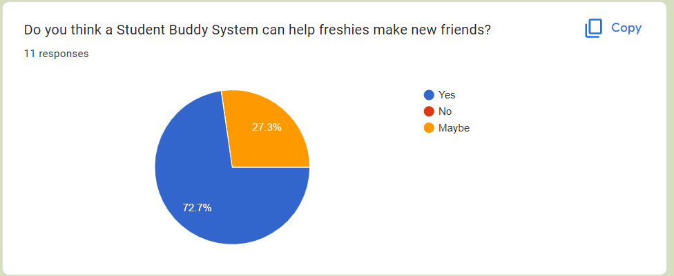

Figure 8: Student Buddy System Survey Responses

**Analysis:** The results above show that up to 72.7% of students agree that a Student Buddy System can help freshmen make new friends, while the remaining students feel skeptical about this statement.

Figure 9: Student Buddy System Survey Responses

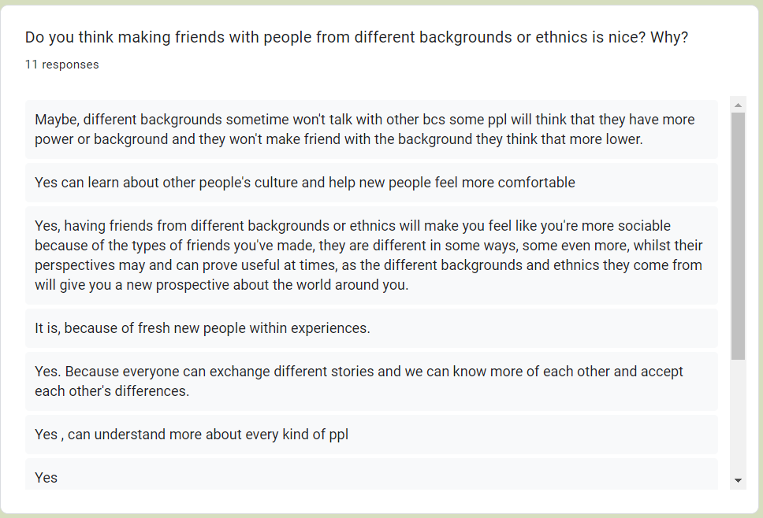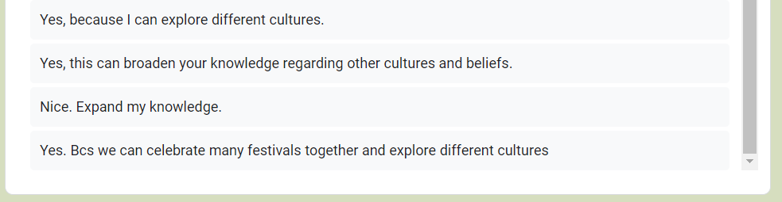

**Analysis:** From all of the responses above, many students think that making friends with people from different backgrounds or ethnics is nice because they get to explore about other people’s culture, expand their knowledge regarding cultures and beliefs and provide them with different perspectives as they come from different parts of the world. While for some, they think that people from different backgrounds might sometimes be proud as they think of themselves as more powerful compared to local students.

Figure 10: Student Buddy System Survey Responses

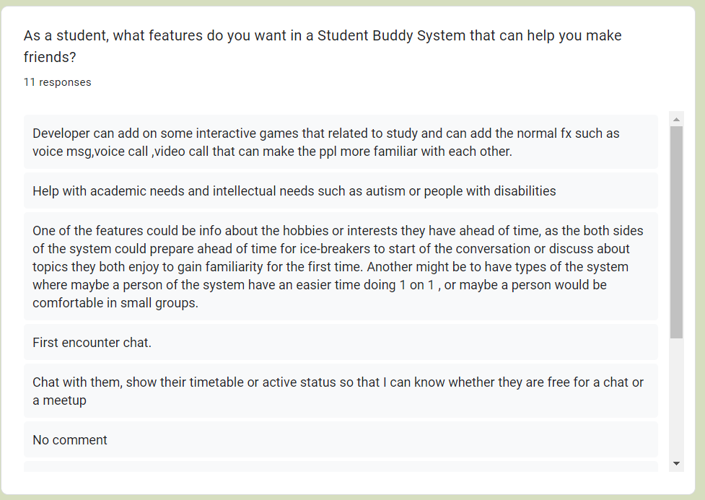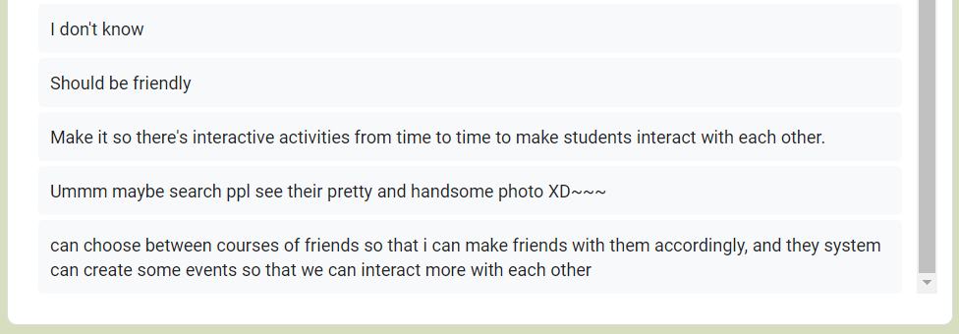

**Analysis:** There are many features the students want to have in a Student Buddy System. Some including seeing their profile, their hobbies and interests, playing interactive games, making video or voice call, the ability to chat with others, see their friends’ timetable to know whether they are free for a meetup or not. They also hope the system is able to create some events for them to further know more about their seniors.

Figure 11: Student Buddy System Survey Responses

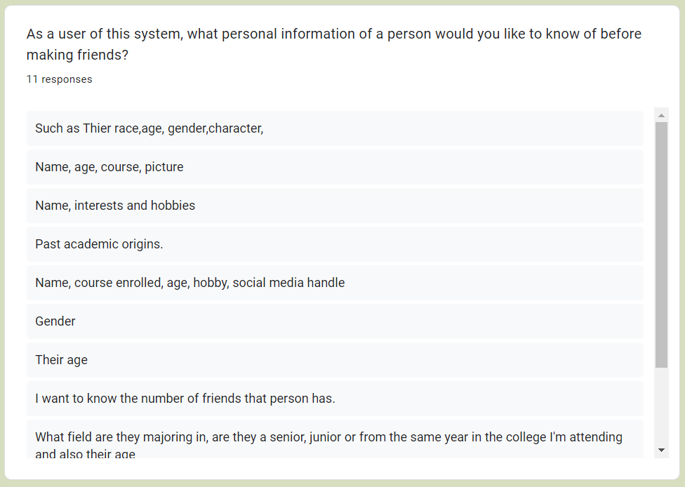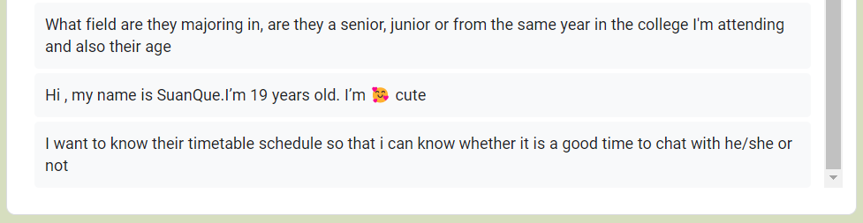

**Analysis:** Before making friends, students would want to know their friend’s personal information including their age, race, gender, interests and hobbies, previous academic origins, courses enrolled and social media handle. This is to further help them know what type of person they will communicate with.

Figure 12: Student Buddy System Survey Responses

about their education, games, life, they also can share their study to other and start a discussion about the studies or make their project, assignment.

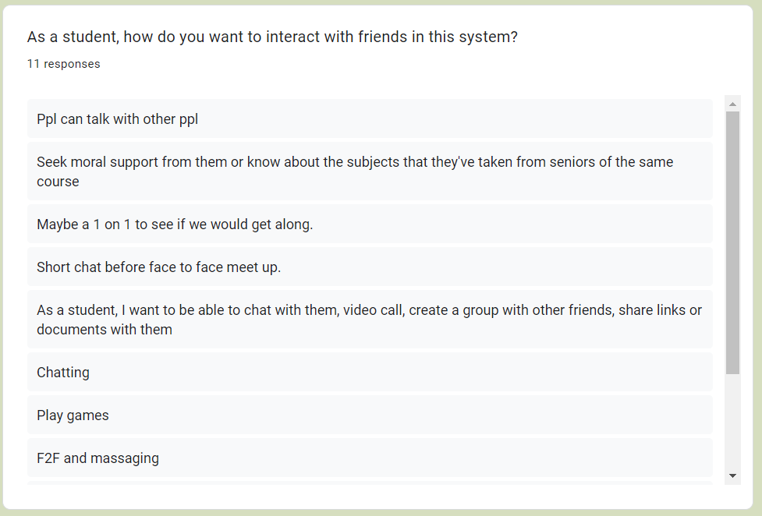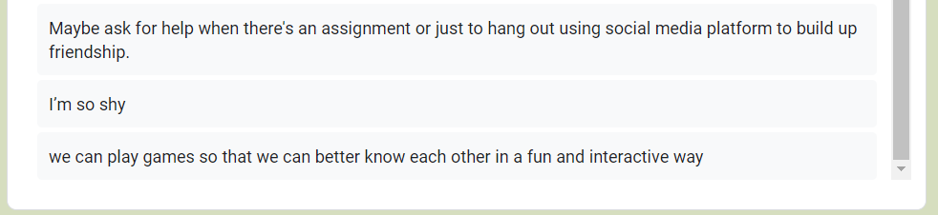

**Analysis:** Based on the survey responses, the students can get along with their seniors by chatting, playing games or meeting up face to face. They can also start a discussion about their studies or assignment so they could share knowledge between each other. Some students might be shy to interact in this system, seniors can help them to talk it out and not let them be so afraid.

Figure 13: Student Buddy System Survey Responses

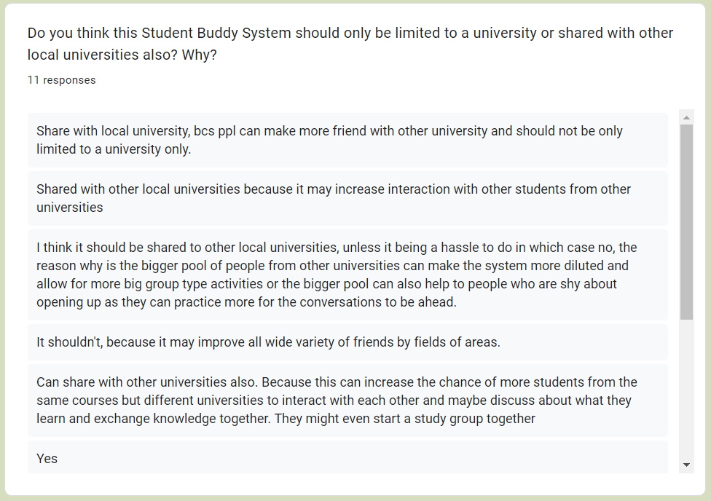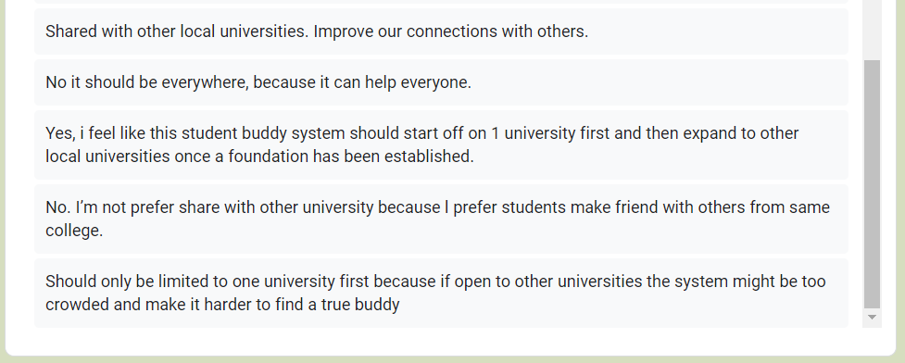

**Analysis:** From the mixed responses above, some students think that the Student Buddy System should only be limited to a university itself because the system may become more diluted and make it harder to find friends, some shy students might find it harder opening up to a bigger group of students, some just prefer making friends from the same university. The students that agree to share the system to other local universities think that because they get to make more friends from other universities and improve connection with others.

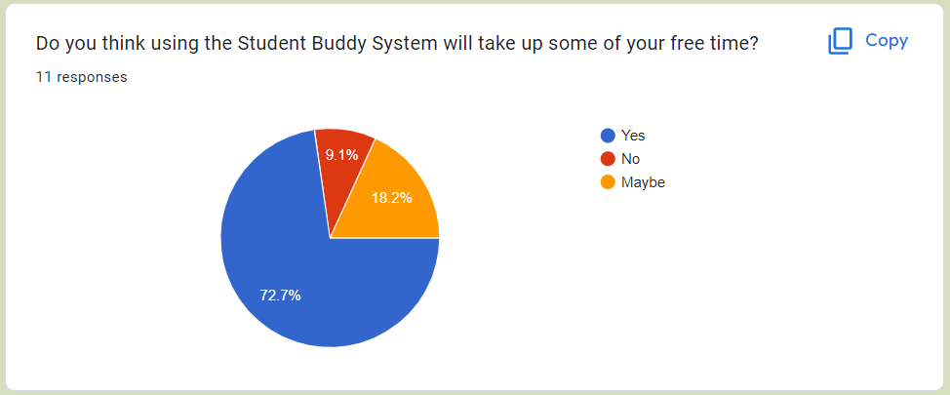

Figure 14: Student Buddy System Survey Responses

**Analysis:** From the figure above, a lot of students think that using the Student Buddy System will take up some of their free time. For a few, they are unsure whether this might use up some of their free time or not. But, a small number of students think that it won’t take up their free time.

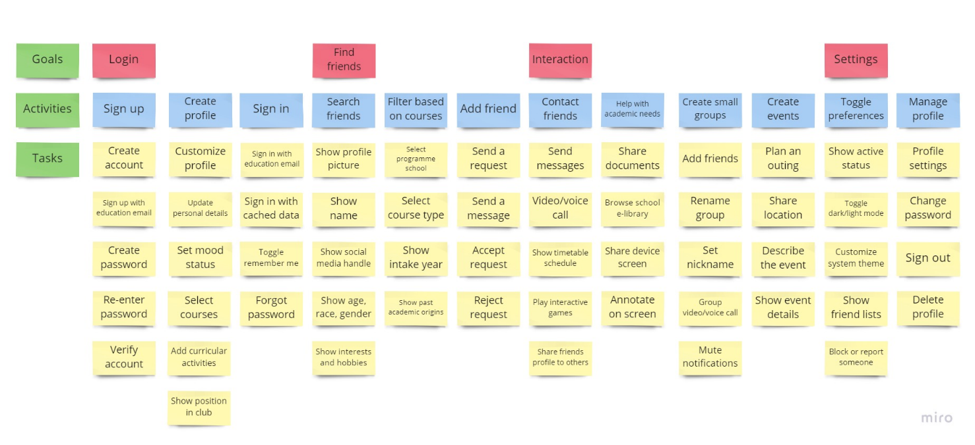

Figure 15: User Story Mapping for Student Buddy System (User is Students)